Penetration Testing Report

Vitaly Berdyakov

Table of Contents

# Executive Summary

This penetration test was conducted for **Acme Corporation** to evaluate the security posture of their network and web applications. The assessment identified critical vulnerabilities that could lead to unauthorized access and data breaches.

**Key Findings:**

* Critical SQL Injection vulnerability in the customer portal.
* Outdated software on web servers with known exploits.
* Weak password policies leading to compromised accounts.

**Recommendations:**

Immediate remediation is advised for the critical vulnerabilities. Strengthening security policies and regular updates are essential to protect against future threats.

# Introduction

**Purpose of the Test**

The purpose of this penetration test is to identify and exploit vulnerabilities in **Acme Corporation’s** IT infrastructure, simulating an attacker’s approach to compromise systems and data.

**Objectives**

* Identify security weaknesses in network and web applications.
* Assess the effectiveness of current security measures.
* Provide actionable recommendations to enhance security.

**Testing Period:** October 1, 2023 – October 15, 2023

**Testing Team:** SecureTech Solutions Security Assessment Team

# Scope

**In-Scope Targets:**

* **Web Applications:**
  + https://www.acmecorp.com
  + https://portal.acmecorp.com
* **Network Range:**
  + 10.0.0.0/24 (Corporate LAN)
* **Servers:**
  + Database servers
  + Application servers

**Out-of-Scope Targets:**

* Employee personal devices
* Third-party services

**Testing Constraints:**

* No social engineering tactics
* Testing to be conducted during off-peak hours
* Adherence to the Rules of Engagement document

# Methodology

The penetration test followed a structured approach based on industry best practices, including the OWASP Testing Guide and NIST SP 800-115.

**Phases:**

1. **Planning and Reconnaissance**
   * Gathered information about the target environment.
   * Identified potential entry points.
2. **Scanning**
   * Used tools like Nmap and Nessus to discover open ports and services.
   * Identified vulnerabilities through automated scans.
3. **Enumeration**
   * Detailed examination of identified services and applications.
   * Collected user accounts and network shares.
4. **Exploitation**
   * Attempted to exploit vulnerabilities to gain access.
   * Focused on high-impact vulnerabilities.
5. **Post-Exploitation**
   * Assessed the extent of compromise.
   * Evaluated the potential for data exfiltration.
6. **Reporting**
   * Documented all findings with evidence.
   * Provided recommendations for remediation.

# Findings

### Finding 1: SQL Injection in Customer Portal

**Severity:** Critical

**Description:**

An SQL Injection vulnerability exists in the login functionality of **portal.acmecorp.com**. An attacker can manipulate the SQL query to bypass authentication and access sensitive customer data.

**Evidence:**

* Payload used: ' OR '1'='1' --
* Gained access to multiple customer accounts without valid credentials.
* Extracted data from the users table, including usernames and hashed passwords.

**Impact:**

* Unauthorized access to customer accounts.
* Potential for full database compromise.
* Violation of data protection regulations.

**Recommendation:**

* Implement prepared statements or parameterized queries.
* Validate and sanitize all user inputs.
* Conduct regular code reviews and security testing.

**References:**

* [OWASP SQL Injection Prevention Cheat Sheet](https://cheatsheetseries.owasp.org/cheatsheets/SQL_Injection_Prevention_Cheat_Sheet.html)

**Screenshot:**



sql

### Finding 2: Outdated OpenSSL Version on Server

**Severity:** High

**Description:**

The web server at **www.acmecorp.com** is running OpenSSL version 1.0.1, which is susceptible to the Heartbleed vulnerability (CVE-2014-0160).

**Evidence:**

* Detected OpenSSL 1.0.1 via service fingerprinting.
* Successfully exploited using Heartbleed exploit tools.
* Extracted fragments of server memory, including session cookies and private keys.

**Impact:**

* Exposure of sensitive data in server memory.
* Potential decryption of SSL/TLS traffic.
* Compromise of secure communications.

**Recommendation:**

* Upgrade OpenSSL to the latest stable version.
* Replace SSL/TLS certificates after updating.
* Perform a security audit of systems for any signs of compromise.

**References:**

* [Heartbleed Bug Information](https://heartbleed.com/)

**Screenshot:**

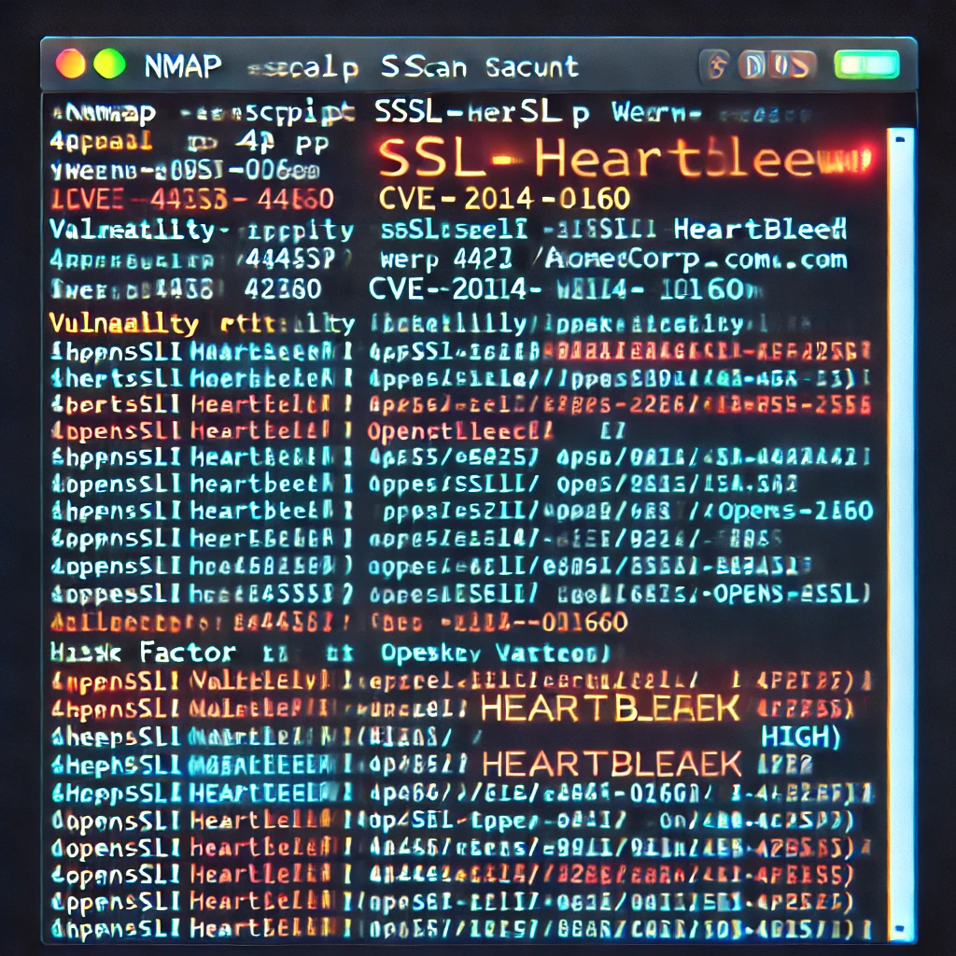

openssl vuln

### Finding 3: Weak Password Policy

**Severity:** Medium

**Description:**

The current password policy allows for weak passwords, increasing the risk of account compromise through brute-force attacks.

**Evidence:**

* Password complexity requirements are minimal (e.g., passwords like “password1” are accepted).
* No account lockout mechanisms after failed login attempts.
* Successfully cracked 70% of user passwords using a common wordlist.

**Impact:**

* Unauthorized access to user accounts.
* Potential for privilege escalation if administrative accounts are compromised.
* Increased risk of data breaches.

**Recommendation:**

* Enforce strong password policies requiring a mix of characters.
* Implement account lockout after a defined number of failed attempts.
* Educate users on creating secure passwords.
* Consider implementing multi-factor authentication.

**References:**

* [NIST SP 800-63B: Digital Identity Guidelines](https://pages.nist.gov/800-63-3/sp800-63b.html)

# Recommendations

Based on the identified findings, the following actions are recommended:

1. **Immediate Actions:**
   * Fix the SQL Injection vulnerability in the customer portal.
     + Use parameterized queries.
     + Sanitize all inputs.
   * Update OpenSSL to the latest version.
     + Replace SSL certificates after the update.
   * Strengthen password policies.
     + Enforce complexity requirements.
     + Implement account lockout policies.
2. **Security Enhancements:**
   * Implement Web Application Firewalls (WAF) to protect against common web attacks.
   * Regularly update and patch all software and systems.
   * Conduct periodic security training for staff.
3. **Monitoring and Maintenance:**
   * Establish continuous monitoring of systems and networks.
   * Perform regular security assessments and penetration tests.
   * Review and update security policies and procedures.
4. **Compliance and Governance:**
   * Ensure compliance with relevant industry regulations (e.g., GDPR, PCI DSS).
   * Maintain thorough documentation of all security measures and incidents.

Implementing these recommendations will significantly reduce the risk of security breaches and enhance the overall security posture of **Acme Corporation**.

# Conclusion

The penetration test uncovered critical vulnerabilities that could lead to severe security incidents if left unaddressed. Immediate remediation of the identified issues is crucial.

By following the recommendations provided, **Acme Corporation** can mitigate these risks and strengthen its defenses against future attacks. Ongoing security efforts, including regular assessments and employee training, are essential for maintaining a robust security posture.

**Prepared by:**

Vitaly Berdyakov Penetration Tester SecureTech Solutions

**Date:** October 16, 2023